**Lesson Notes**

1. What is the main purpose of an Operating System?

* Simpler / More Efficient Application Programs
* Operating System handles the Computer Hardware
* Operating System handles resource allocation
* Consistent User Experience
* Operating System provides a standard User Interface (Windows)
* Operating System provides a standard way to store and browse data files and folders (File Explorer)
* Allow Multiple Applications Running At Same Time
* Operating System Provides Ownership Control (User Accounts)
* Operating System Schedules the CPU (Task Sharing)

1. What is the difference between Operating System Software and Use Application Software?

* Hardware Independence
  + Same applications can run on different computer hardware
  + Operating System must be configured according to hardware components present in the computer
  + User Interface
  + Applications focus on what is contained and displayed within a window
  + Operating System controls opening / closing / resizing windows and responding to mouse and keyboard actions
  + Operating System provides standard ways to print, save and open files, access the internet, etc.
  + Resource Allocation
  + Applications just ask for what they need (e.g. Memory, Disk Space)
  + Operating System checks for availability and access permission
  + Operating System coordinates resource allocation between applications

1. What is the difference between Operating System Software and Computer Hardware?

Computer system software is software that has other programs on it while computer hardware is the physical components of the computer like RAM and hard drives.

1. What are the main parts of an Operating System?

* Graphical User Interface (GUI)
  + Windows Display, mouse, keyboard, sound, etc.
* System Calls
* Device Drivers
* I/O Manager
* Memory Manager
* Process Manager
* Security Monitor

1. What are some popular operating systems?

* Windows OS
* Mac OS
* Linux / Unix
* Android
* iOS

**Reference Diagram**

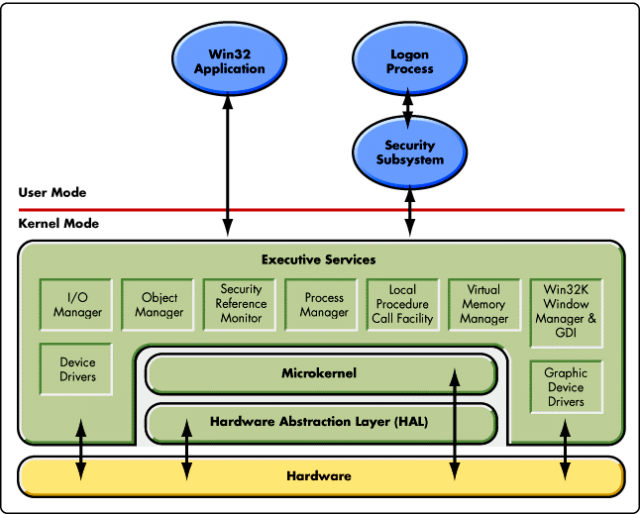

**Student Questions**

1. What is a device driver?
   1. Provide a brief summary

In computing, a device driver is a computer program that operates or controls a particular type of device that is attached to a computer. It is also a file that lets the computer know the configuration and specifications of a certain hardware device.

* 1. List some devices that require a device driver.
* Printers
* Displays
* CD ROM readers
* Network and sound cards
* Computer mice
* Hard disks
  1. Provide a label on the reference diagram for the location of a device driver for your graphics card.



Graphics card device driver

* 1. Provide a label on the reference diagram for the location of a device driver for a locally attached printer.



Locally attached printer

1. What is a DLL?
   1. Provide a brief summary

Dynamic-link library is Microsoft's implementation of the shared library concept in the Microsoft Windows and OS/2 operating systems

* 1. Explain how DLLs are related to user application programs

DLLs let user application programs do certain functions that can be used by more than one program. For example, there can be a DLL to open a dialogue box and any program that needs to do that can use the DLL.

* 1. Provide a label on the reference diagram for the location of a DLL



DLL

1. What is a windows manager?
   1. Provide a brief summary

It manages how all the windows are created by various applications and who gets the application input.

* 1. Explain how a windows manager is related to user application programs

Because it decides what application is getting input and which application the user is using.

* 1. Provide a label on the reference diagram for the location of a windows manager



Windows manager

1. What is the windows task manager?
   1. Provide a brief summary

  Task Manager is a Windows feature that provides details about programs and processes running on your computer. It also displays the most commonly used performance measures for processes.

* 1. List and explain four (4) types of system information provided by the task manager

  It provides information about computer performance and running software, including name of running [processes](https://en.wikipedia.org/wiki/Process_(computing)), [CPU](https://en.wikipedia.org/wiki/CPU) load, [commit charge](https://en.wikipedia.org/wiki/Commit_charge), [I/O](https://en.wikipedia.org/wiki/I/O) details, logged-in users, and [Windows services](https://en.wikipedia.org/wiki/Windows_service).

* 1. Provide a label on the reference diagram for the operating system components related to each type of information.



Operating system components